Ladies Only!!!
The Ground Floor
Strengthening the Pelvic Floor
By Donna Schnoor
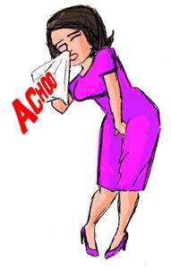
A Workshop to discuss Pelvic Floor Dysfunction and exploring techniques and exercises to identify and strengthen these muscles.
*Hypotonicity vs Hypertonicity
*Urinary incontinence
*Pelvic Organ Prolapse
*Weakened muscles due to childbirth or age
*Lower estrogen levels

Saturday, April 1
1:00- 3:00pm
$10.00 members- due upon sign-up
Registration takes place in yoga room during regular class time
Must be a Sun City Hatha Yoga Club Member – Mat Students Only
Refunds only if SC Hatha Yoga Club cancels workshop

- A handout detailing the techniques & exercises we address
will be given to each participant to take home for reference.

